


Building and Operating a Mini Security Operations Center (SOC)

Under supervision of Eng: Wessam Elkhaligy

Made by " Threat Shield Alliance "

team members:

Abanob Hany Roushdy

Abdelrahman Ahmed

Aya Mohamed Mahmoud Zaki

Mohamed Abdelgawad Elnoamani

Omar Samy Samir

1. Project Planning

Objective
To build a small Security Operations Center (SOC) to find and report on security threats. The project involves:
- Setting up Elastic SIEM.
- Collecting logs from Windows, Linux, and a pfSense firewall.
- Finding 3-5 attacks (like brute force).
- Analyzing the alerts.
- Creating a final report.

Technology Stack
- SIEM: Elastic SIEM (Elasticsearch & Kibana)
- Firewall: pfSense
- IDS: Suricata (running on victim VMs)
- Log Shipper: Winlogbeat , Filebeat (Elastic Agents)
- Victims: Windows 10 & Ubuntu
- Attacker: Kali Linux
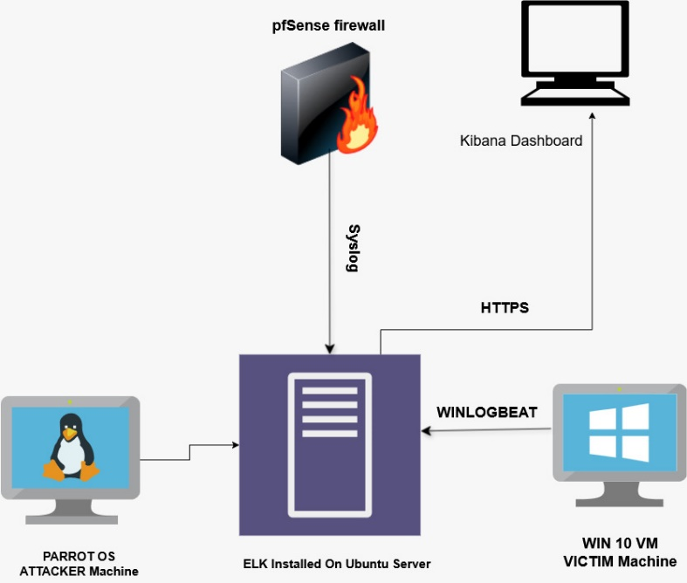

High-Level SOC Network Architecture and Data Flow Diagram.

SOC Architecture
This diagram shows how logs flow from your devices to the SIEM.
- Devices:
  - pfSense Firewall: Sends Syslog data (firewall rules, traffic) to the SIEM.
  - Windows 10 & Ubuntu Victims:
    - Run Elastic Agents to send their own logs (Windows Events, Sysmon, Linux auth.log).
    - Run Suricata (IDS), which creates an eve.json log. Elastic Agents reads this file and sends it to the SIEM.
- SIEM:
  - Elastic Stack: Receives all logs, organizes them, and provides the Kibana (UI) for analysis.

2. Stakeholder Analysis
This project has two main stakeholders (people involved).
Stakeholder | Their Role | What They Need
Project Instructor | Evaluator | To see a working system that meets all project goals. They will grade the final report and presentation.
Project Partner | Teammate | To have clear tasks, good communication, and shared access to the project to get a good grade.

3. Database Design (Data Ingestion)
This section explains how we collect and store data in our "database" (Elasticsearch).
- Database: Elasticsearch
- Schema (Format): Elastic Common Schema (ECS). We format all logs into ECS so we can search source.ip (and other fields) from any log source (firewall, Windows, etc.) using one name.

Data Collection Plan
Log Source | Tool Used | Logs Collected | Destination Index (in Elastic)
pfSense | Syslog | Firewall traffic (allow/deny) | logs-firewall-pfsense
Windows 10 | Winlogbeat | System, Security, Application, & Sysmon logs | logs-windows-sysmon
Ubuntu | Filebeat | auth.log (logins) & syslog | logs-linux-auth
Suricata (on victims) | Elastic Agents | eve.json (IDS alerts, network traffic) | logs-ids-suricata

4. UI/UX Design (Kibana Dashboards)
This is the plan for the "front-end" of our SOC, which we will build in Kibana. We will create simple dashboards for analysis.

Dashboard 1: Alert Triage
- Purpose: The main screen to see and handle new alerts from Elastic SIEM and Suricata.
- Design:
  - A list of new alerts.
  - A pie chart showing "Alerts by Severity" (High, Medium, Low).
  - A bar chart showing "Top 5 Alert Types" (e.g., "Brute Force," "Malware").

Dashboard 2: Network & Endpoint Monitoring
- Purpose: To see what is happening on the network and on our victim machines.
- Design:
  - A list of all pfSense firewall "denied" traffic.
  - A list of all successful and failed logins (from Windows & Ubuntu).
  - A timeline of Sysmon events (like new processes starting).

